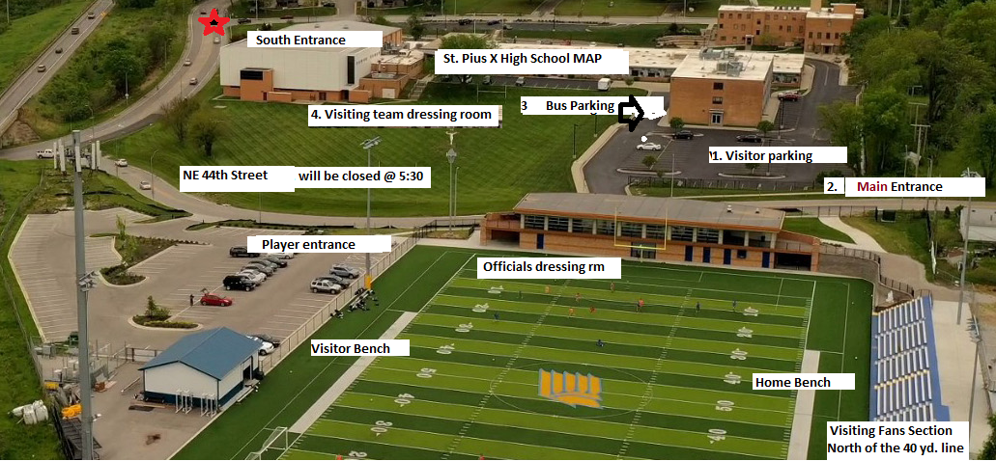

SPX Visitors directions. (We encourage masks and ask that you observe social distancing for those outside of your family.) No limits on capacity!

For visiting Teams: (See above)

# 1 – There are two parking lots available. One directly adjacent to the football stadium on the east side. There is a second lot to the south of the football stadium that surrounds our school. The Visitors Entrance is directly North of the Visitor Parking lot (MAIN Entrance) across the road (NE 44th street) This road will be blocked off (closed to public traffic) during the game and only those individuals coming to the game will be allowed on this street. Enter NE 44th or NE 42nd Terr. off of NE Davidson (Use the Davidson Rd exit off of 29 South or 35 North Hiway)
NOTE: The street south of the stadium (44th Street) will be closed at approximately 5:30. To Park After 5:30 use the South entrance NE 42nd Terrace.

Admission Fee is $5.00 for Adults $3.00 for students.

For JV games fee is $3.00 $2.00 for students

# 2 – The Main entrance is along NE 44th Street on the way to stadium seating. Please encourage fans to wear masks, they are not mandatory for entrance.

# 3 – BUSES for the Team: Please back in buses and park along the 3-story wing next to the building side curb (West curb). The buses should be facing North when parked.

# 4 - For those individuals who have mobility issues. They can be dropped off at the upper level gate on the south end of the stadium and or can be transported via golf cart to that entrance upon request.

Visiting Fans are asked to sit on the NORTH end of the 40 yd. line in the bleachers.

