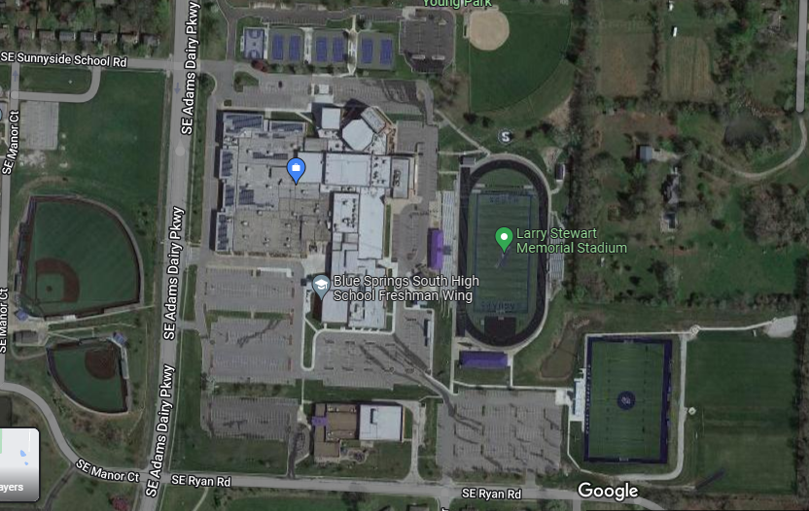
RESERVED LOT

Directions:
- Team busses should enter Blue Springs South campus at either entrance indicated with YELLOW arrows above.

- Busses should travel to their parking spot following the BLUE arrows.

- Busses will park next to the visitor locker room at the GREEN arrow.

- There will be gate workers to help busses get into their parking lot next to the locker rooms.

