NORTH KANSAS CITY HIGH SCHOOL

**C-Team VOLLEYBALL TOURNAMENT**

**October 7, 2023**

|  |  |  |  |  |
| --- | --- | --- | --- | --- |
| **White-FH Ct 1** | **Black-FH Ct2** | **Purple-Aux** | **Gold-Norclay Ct 1** | **Red- Norclay Ct 2** |
| 1. Lee’s Summit North  2. Kearney  3. Pembroke Hill  4. Lone Jack | 1. Park Hill South  2. St. Joe Central  3. St. Pius  4. Maryville | 1. Park Hill  2. Smithville  3. NKC | 1. Liberty  2. Grain Valley  3. St. Teresa’s  4. Tonka | 1. Liberty North  2. Platte County  3. ND de Sion  4. Aquinas |

# POOL PLAY – 4 team pools will play 2 games, start @ 6-6, cap 27. 3 team pools will be best 2/3, start @ 0-0, cap 27, 3rd set 15

8:00 3 vs 1 1 vs 2

Rd 2 4 vs 2 2 vs 3

Rd 3 1 vs 4 3 vs 1

Rd 4 2 vs 3 --------

Rd 5 3 vs 4 --------

Rd 6 1 vs 2 --------

*The first team listed will be the home team

**TOP 3 TEAMS FROM EACH POOL ADVANCE TO BRACKET PLAY**

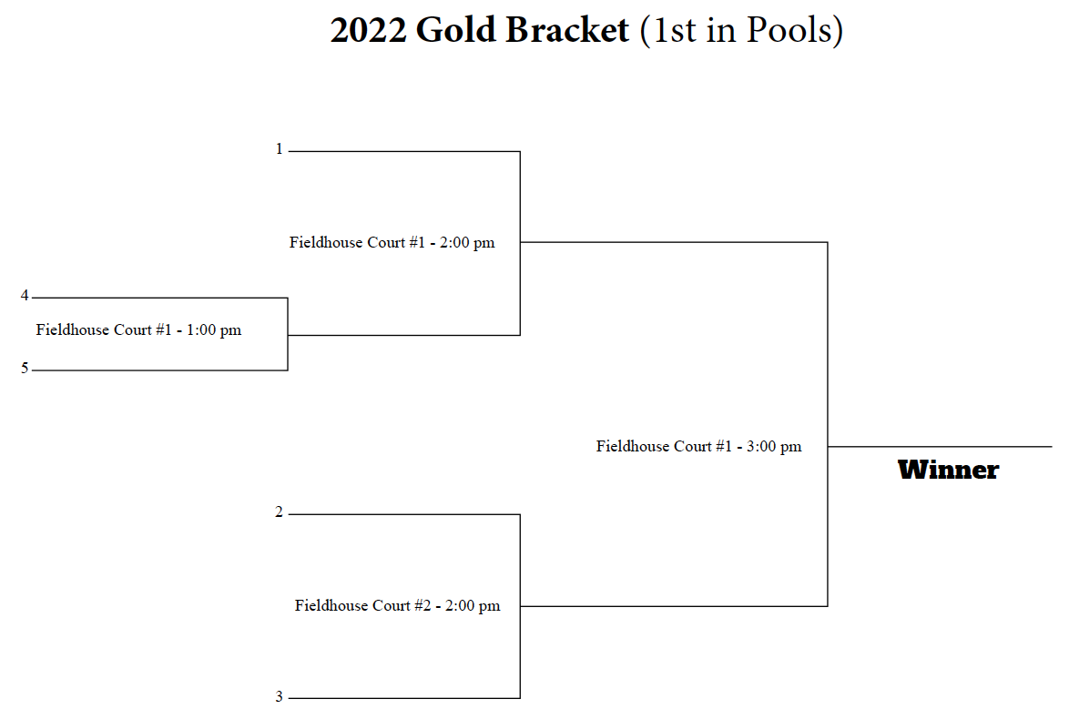

Gold Bracket (1st in Pools)

Silver Bracket (2nd in Pools)

Bronze Bracket (3rd in Pools)