TRUMAN HIGH SCHOOL
3301 S. Noland Road – Independence, MO 64055
Phone 816-521-5350 – Fax 816-521-5604
Daniel Bieser, Activities Director, daniel_bieser@isdschools.org
Marilyn Reinhard, Administrative Assistant, marilyn_reinhard@isdschools.org
******************************************************************************************
44th Annual Truman High School Girls’ Varsity Volleyball Tournament
October 17, 2020

The “44th Annual Truman High School Girls’ Varsity Volleyball Tournament” will take place on Saturday, October 17, 2020.

The gym doors will open at 7:00 am with warm up starting at 7:40 am and game time at 8:00 am

LOCATION: Truman High School, 3301 S. Noland Road, Independence, MO 64055

TOURNAMENT DIRECTOR: David Gardner, Head Volleyball Coach

TEAMS: Kearney, Lee’s Summit, Lee’s Summit West, Ray Pec, St. Joseph Central, Staley, Truman and William Chrisman

POOL PLAY TIE BREAKERS
1. Set-Win-loss percentage.
2. Head to head competition.
3. Point differential between tied teams.
4. Point differential in all games.

ENTRY FEE: $225.00 and make check payable to Truman High School and mail to:
Truman High School, Daniel Bieser, AD, 3301 S. Noland Rd., Indep., MO 64055

ADMISSION: NO SPECTATORS ARE ALLOWED

AWARDS: There will be a trophy for the first and second place teams

CRASH AND CONCESSION STAND: There will be a concession stand open during the tournament. Drinks, Candy, and Chips only. Team food and drink will be limited to the crash area. Each team will be designated a classroom to crash in when not playing. Please help all concerned by keeping food and drink in designated areas and policing trash. Teams must stay in the classroom until their designated game time.

HOSPITALITY: There will be NO hospitality room available.

ROSTERS: Please email your school’s team roster (limited to 12)/pass list (page 3) to Marilyn Reinhard by Friday, October 9, 2020, (marilyn_reinhard@isdschools.org).

If you any questions, please contact David Gardner, head volleyball coach, at david_gardner@isdschools.org or 816-521-5350 or Daniel Bieser, Activities Director, 816-521-5350 or daniel_bieser@isdschools.org.

44th Annual Truman Volleyball Tournament
October 17, 2020
Pool and Bracket Information

BLUE Pool RED Pool
- Lee’s Summit 1. Lee’s Summit West
- Kearney 2. Staley
- Ray-Pec 3. St. Joseph Central
- Chrisman 4. Truman

POOL PLAY
8 am 1 VS 4
9 am 2 VS 3
9:50 1 VS 3
10:40 2 VS 4
11:30 1 VS 2
12:20 3 VS 4

The first two rounds of pool play will have a 18 minute warm up. The rest of the matches will have 6 minute warmups.
Starting times are approximate. Next game will begin when court is available.
Pool play will be 2 games to 25 starting at 4 no caps.
Bracket play will be best 2 out of 3 starting at zero playing to 25 no caps.
All teams will make the 8 team bracket
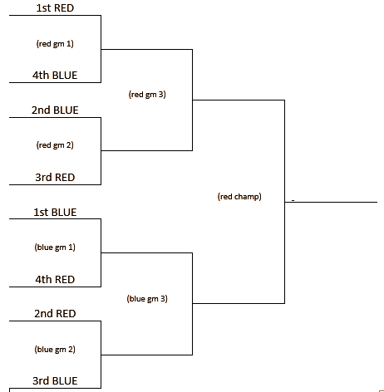

We have line judges and Trackers for this year’s tournament.
Please bring your own warm balls.
Clear benches quickly as we will wipe them down between matches.
Masks must be worn at all times by players and coaches.

VOLLEYBALL ROSTERS— Please send Roster/Pass List by Friday, October 12, 2020, to: marilyn_reinhard@isdschools.org

School Name
Administrators
Head Coach
Assistant Coaches
PASS LIST

TEAM ROSTER
Name Number Grade

1.

2.

3.

4.

5.

6.

7.

8.

9.

10.

11.

12.___________________________________________________________________________________________________

